**Figure 1** Analysis of Mg2+ speciation in *E. coli* metabolitemixtures. **(A)** E. coli metabolome molar composition. Eco80 contains the 15 most abundant metabolites that comprise 80% of the *E. coli* metabolome. NTPCM contains four strong Mg2+ chelating NTPs, and WMCM contains 11 other weak Mg2+ binding metabolites. **(B-D)** Effect of Mg2+ on 8-hydroxyquinoline-5-sulphonic acid (HQS) emission with and without mixtures of metabolites that chelate Mg2+. Grey lines represent fits to determine the binding constant for Mg2+ and HQS in the absence of chelators. **(E-G)** Relationship between the total Mg2+ concentration and the free Mg2+ concentration with mixtures of metabolites that chelate Mg2+. The free Mg2+ concentration (y-axis) was calculated using HQS emission and the binding constant for Mg2+ and HQS. Hex bins represent a statistical simulation of 1000 virtual artificial cytoplasms based on experimental errors in KD determination, experimental errors in reagent concentrations, and single site binding. Triangle data points are free Mg2+ concentrations calculated using HQS emission. Black lines were generated using polynomial regression. The red shaded region is the biological free Mg2+ concentration, 0.5 to 3 mM. The red line is the approximate free Mg2+ concentration in *E. coli*.

**Table 1.** Eco80: the 15 most abundant metabolites which comprise 80% of the *E. coli* metabolome.

|  |  |  |  |
| --- | --- | --- | --- |
| Metabolite | Conc. (mM) | KD  (mM) | Chelation stength |
| ATP | 9.63 (0.963)a | 0.28 (0.01)b | NTPCM (Stronge) |
| UTP | 8.29  (0.829)a | 0.248 (0.004)b | NTPCM (Stronge) |
| GTP | 4.87  (0.487)a | 0.201  (0.007)b | NTPCM (Stronge) |
| dTTP | 4.62  (0.462)a | 0.160  (0.003)b | NTPCM (Stronge) |
| L-Glutamic acid | 96  (9.6)a | 520 (50)c | WMCM (Weake) |
| Glutathione | 16.6  (1.66)a | NAd | WMCM (Weake) |
| Fructose 1,6-bisphosphate | 15.2  (1.52)a | 5.9 (0.1)b | WMCM (Weake) |
| UDP-N-acytylglucosamine | 9.24  (0.924)a | 29 (2)b | WMCM (Weake) |
| Glucose 6-phosphate | 7.88  (0.788)a | 17.3 (0.2)b | WMCM (Weake) |
| L-Aspartic acid | 4.23  (0.423)a | 465 (12)c | WMCM (Weake) |
| L-Valine | 4.02  (0.402)a | NAd | WMCM (Weake) |
| L-Glutamine | 3.81  (0.381)a | NAd | WMCM (Weake) |
| 6-Phospho- gluconic acid | 3.77  (0.377)a | 14.4 (0.2)b | WMCM (Weake) |
| Pyruvic acid | 3.66  (0.366)a | 15.8 (0.9)c | WMCM (Weake) |
| Dihydroxyacetone phosphate | 3.06  (0.306)a | 20 (1)b | WMCM (Weake) |

Auncertainty propagated from uncertainties in reagent masses and volumes used during sample preparation. Extra significant digits included to avoid systematic rounding errors in the statistical model.

bDetermined at 37 °C with Isothermal titration calorimetry as measured in SI figure 1 and SI table 2. Error is the propagated standard error in the fit parameters.

cDetermined at 37 °C with HQS emission as measured in the SI figure 2 and SI table 3. Error is the propagated standard error in the fit parameters.

dNo binding observed as per SI Figure 2.

eMetabolites with KDs for Mg2+ less than 2 mM are considered strong Mg2+ chelators.

**SI Table 1.** Recipe for the Eco80 artificial cytoplasm (Add in later in word when I am formatting the tables)

SI Figure 1 Isothermal titration calorimetry (ITC) analysis of Mg2+ binding to metabolites in 240 mM NaCl 140 mM KCl 10 mM HEPES pH 7.0 at 37 °C. MgCl2 was titrated into metabolites and the power was monitored over time (Top panel). Heat of the injection was calculated by integrating the raw power curve, and the background heat of MgCl2 diltution, collected on buffer containing no metabolite, was subtracted to produce the isotherms in the bottom panels. Lines in bottom pannels represent fits to the Weismann isotherm equation to determine apparent association constants. **(A)** Adenosine triphosphate (ATP). **(B)** Uridine triphosphosphate (UTP). **(C)** Guanosine triphsophate (GTP). **(D)** deoxythymidine triphosphate (dTTP). **(E)** Fructose 1,6-bisphosphate. **(F)** Uridine diphosphate (UDP)-N-acytylglucosamine. **(G)** Glucose 6-phosphate. **(G)** 6-phosphogluconic acid. **(H)** phosphoenol pyruvate. **(G)** Ethylene diamine-tetracetic acid (EDTA). Thermodynamic values are found in SI table 2.

SI Table 2 Apparent binding constants determined with Isothermal titration calorimetry (ITC).

|  |  |  |  |  |  |
| --- | --- | --- | --- | --- | --- |
| Metabolite | Syringe (mM) | Cell (mM) | ΔH (kcal/mol) | K’ (M-1) | KD’ (mM-1) |
| ATP | 15 mM MgCl2a | 0.1 mM ATPa | 1.83 (0.04) | 3600 (200) | 0.28 (0.01) |
| UTP | 15 mM MgCl2a | 0.2 mM UTPa | 1.70 (0.01) | 4200 (70) | 0.248 (0.004) |
| GTP | 15 mM MgCl2a | 0.2 mM GTPa | 1.43 (0.02) | 5000 (200) | 0.201 (0.007) |
| dTTP | 15 mM MgCl2a | 0.2 mM dTTPa | 2.19 (0.02) | 6300 (300) | 0.160 (0.003) |
| Fructose 1,6-BP | 100 mM MgCl2a | 5.0 mM Fructose 1,6-BPa | 0.414 (0.004) | 169 (4) | 5.9 (0.1) |
| UDP-GlcNAC | 100 mM MgCl2a | 5.0 mM UDP-GlcNAC | 0.57 (0.02) | 34 (2) | 29 (2) |
| Glucose 6-P | 100 mM MgCl2a | 5.0 mM Glucose 6-Pa | 0.555 (0.003) | 57.9 (0.7) | 17.3 (0.2) |
| 6-P-gluconic acid | 100 mM MgCl2a | 5.0 mM 6-P-gluconic acida | 0.662 (0.005) | 70 (1) | 14.4 (0.2) |
| Dihydroxyacetone phosphate | 100 mM MgCl2a | 5.0 mM dihydroxy-acetone phosphatea | 0.50 (0.01) | 51 (3) | 20 (1) |
| EDTA | 6 mM MgCl2a | 1.5 mM EDTA 1.0 mM MgCl2a,b | 2.85 (0.04) | 220,000 (30,000) | 0.0045 (0.0006) |

a240 mM NaCl 140 mM KCl 10 mM HEPES pH 7.0 at 37 °C

bMg2+ and EDTA were incorporated into the cell in order to sequester trace tight binding metal ions and thereby negate their contribution to ITC signal.

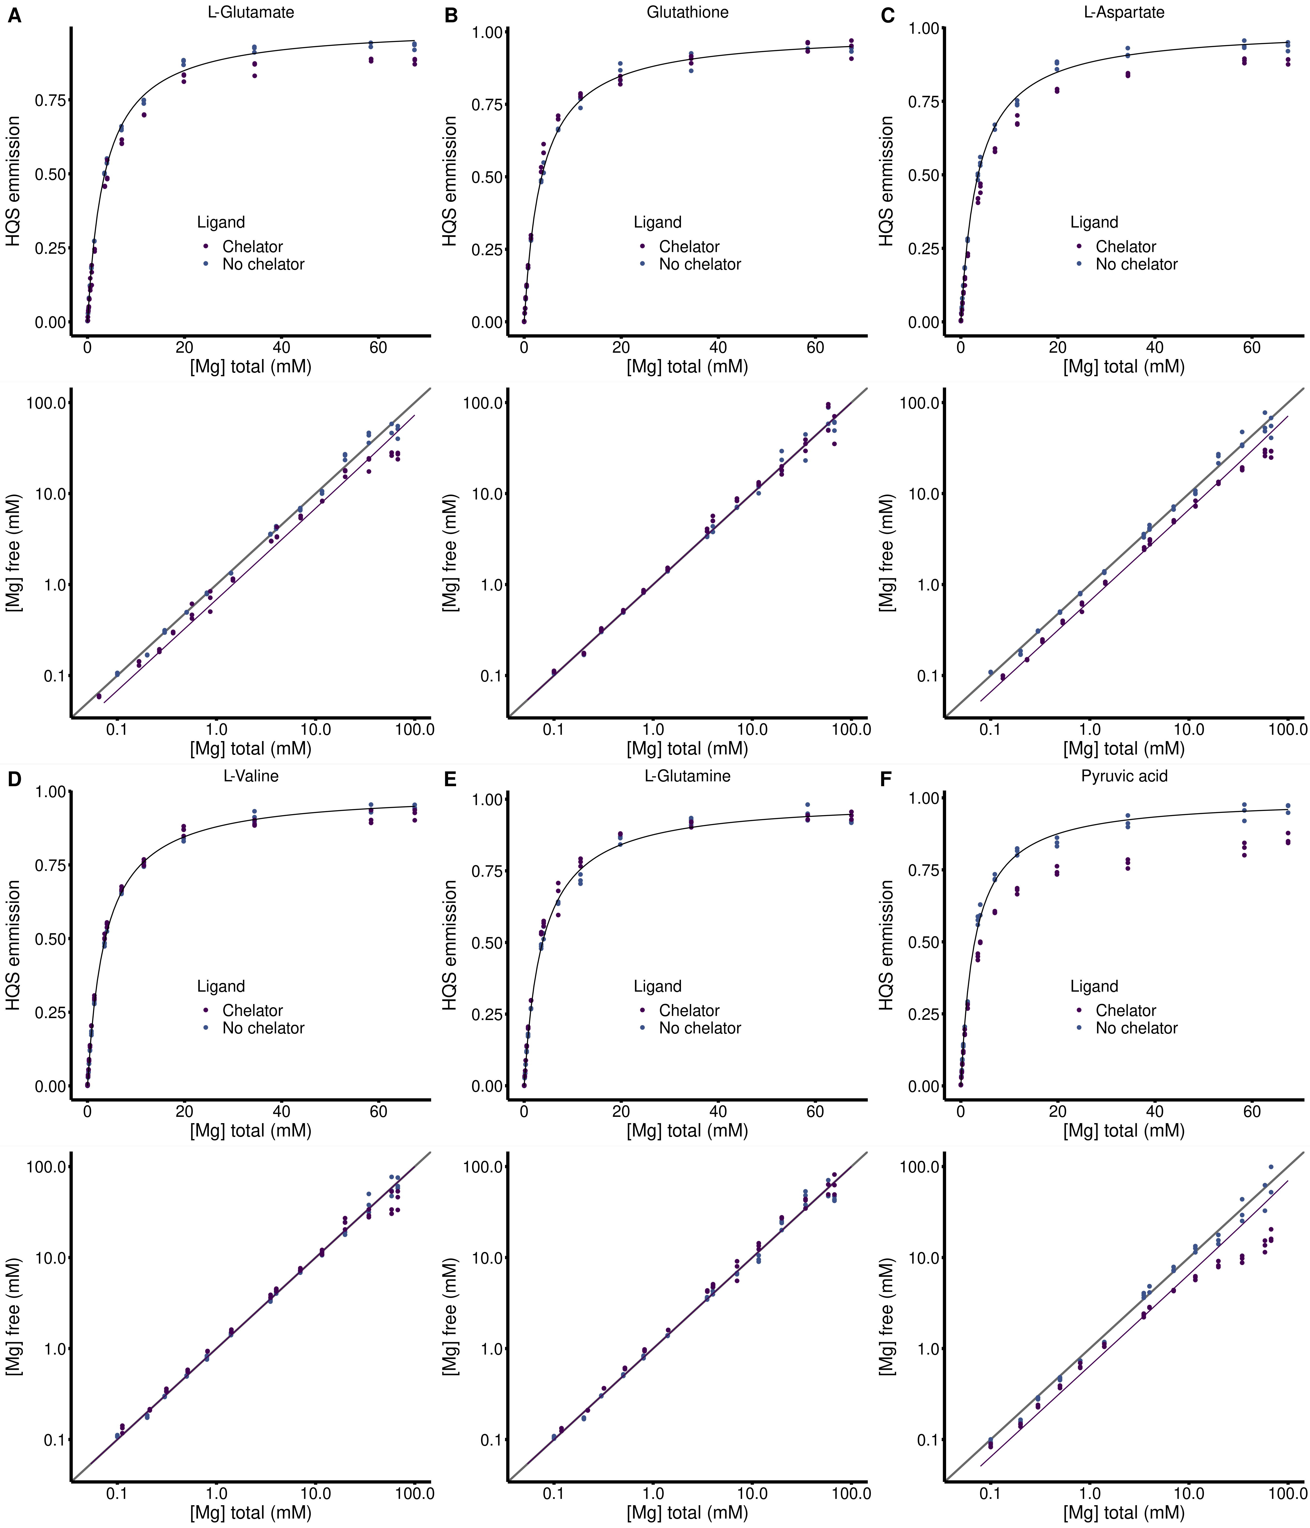**SI Figure 2** HQS analysis of Mg2+ binding to metabolites in 240 mM NaCl 140 mM KCl 20 mM MOPS 0.01 mM EDTA 0.001% SDS pH 7.0. (Top panels) Dependence of HQS emission on the total concentration of MgCl2 in the presence and absence of a metabolite chelators. Black lines represent a fit to SI equation 1 to determine the Fmax, Fmin, and KHQS. (Bottom panels) Dependence of the free Mg2+ concentration on the total concentration of MgCl2 in the presence and absence of a metabolite chelators. Grey lines represent where the free Mg2+ concentration equals the total concentration of MgCl2, Purple lines represent a fit to SI equation 4 to determine the association constant between HQS and a chelator. **(A)** 240 mM L-glutamate. **(B)** 194 Glutathione. **(C)** 240 mM L-aspartate. **(D)** 240 mM L-valine. **(E)** 240 mM L-glutamine. **(F)** 5 mM pyruvic acid.

SI Table 3 Apparent binding constants determined with HQS emission. Fmax, Fmin, and KHQS are determined by fitting HQS emission in the absence of chelators and used to calculate the free Mg2+ concentration in each sample. Metabolite binding constants, K’ and KD’. are determined by fitting the relationship between the free Mg2+ concentration and the total MgCl2 concentration using SI Equation 4.

|  |  |  |  |  |  |
| --- | --- | --- | --- | --- | --- |
| Metabolite | Fmax | Fmin | KHQS (mM-1) | K’ (mM-1) | KD’ (mM-1) |
| L-Glutamic acid | 187,000 (1000) | 0 (810) | 0.281 (0.008) | 0.0019 (0.0002) | 520 (50) |
| Glutathione | 182,000 (1000) | 592 (750) | 0.279 (0.007) | NAc | NAc |
| L-Aspartic acid | 196,000 (1000) | 0 (820) | 0.283 (0.007) | 0.0021 (0.0001) | 465 (12) |
| L-Valine | 188,200 (800) | 495 (580) | 0.274 (0.005) | NAc | NAc |
| L-Glutamine | 190,000 (1400) | 516 (110) | 0.27 (0.01) | NAc | NAc |
| Pyruvic acid | 188,000 (1500) | 0 (1300) | 0.35 (0.01) | 0.063 (0.003) | 15.8 (0.9) |

cNo binding observed as per SI Figure 2

**SI Table 3.** HQS fits in the absence of chelators, used to determine free Mg2+ concentrations. Fmax, Fmin, and KHQS are determined by fitting HQS emission in the absence of chelators and used to calculate the free Mg2+ concentration in each sample.

|  |  |  |  |
| --- | --- | --- | --- |
| Metabolite | Fmax | Fmin | KHQS (mM-1) |
| Eco80 | 185,100 (800) | 124 (1000) | 0.239 (0.005) |
| NTPCM | 187,000 (1500) | 436 (1000) | 0.26 (0.01) |
| WMCM | 179,000 (1600) | 0 (1400) | 0.32 (0.01) |

Table 2. Total Mg2+ concentrations used to obtain 2 mM free Mg2+ in artificial cytoplasm.

|  |  |  |  |
| --- | --- | --- | --- |
| Condition | Total [Mg2+] (mM) | Chelated [Mg2+] (mM) | Free [Mg2+] (mM) |
| Eco80 | 31.6 | 29.6 | 2.0 |
| NTPCM | 25.0 | 23 | 2.0 |
| WMCM | 6.4 | 4.5 | 2.0 |

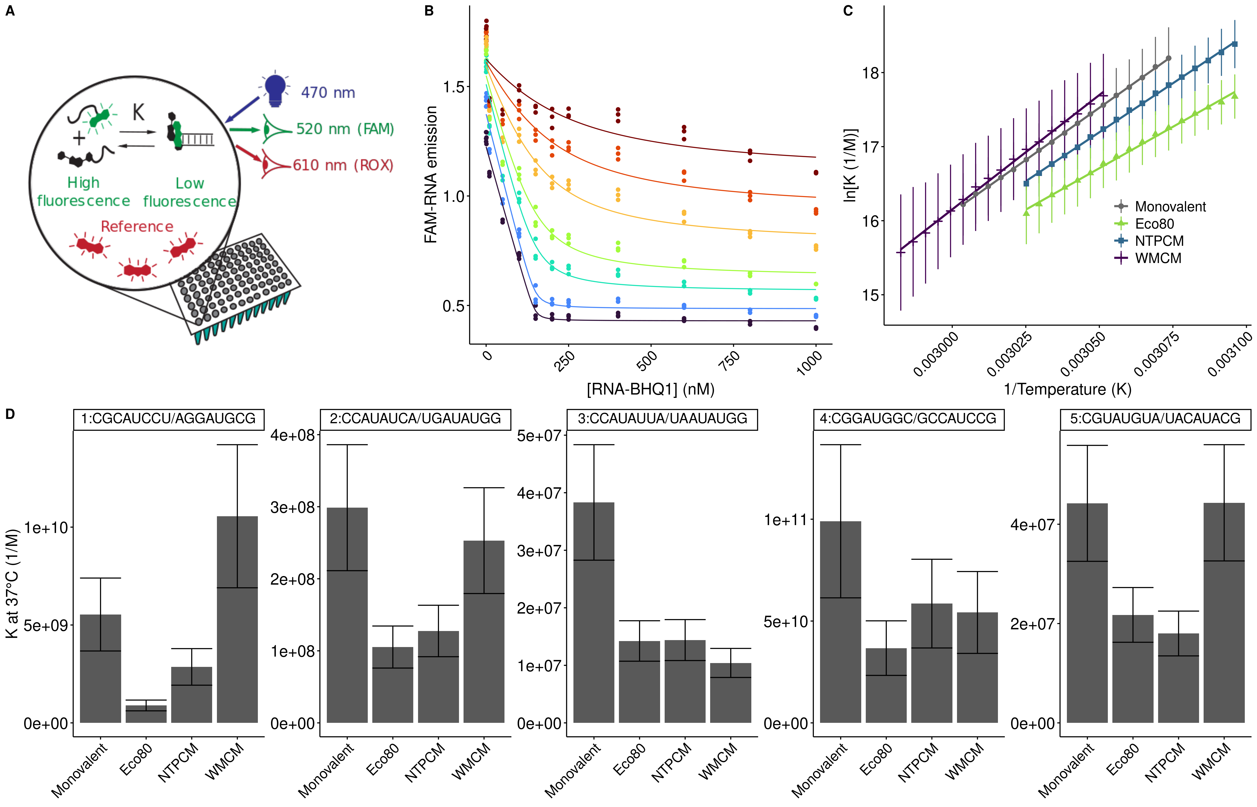**Figure 2** *E. coli* metabolite and Mg2+ mixtures destabilize RNA secondary structure. Helix folding energies in Eco80, NTPCM, and WMCM were determined using fluorescence binding isotherms that are fit with the MeltR program. **(A)** Layout of a fluorescence binding isotherms assay to determine helix folding energies in Eco80, NTPCM, and WMCM, in a Real-Time PCR machine. **(B)** Raw fluorescence binding isotherms fit to determine equilibrium constants with MeltR. Data points represent raw data. Curves represent curve fits. Colors represent different temperatures (purple: 32.3, blue: 41.8, teal: 51.3, green: 54.6, yellow: 58.4, orange: 60.7, red: 63.1 °C). **(C)** Van’t Hoff relationship between equilibrium constant and temperature for helix 1:CGCAUCCU/AGGAUGCG folding in background monovalent metal ions (240 mM NaCl 140 mM KCl), Eco80, NTPCM, and WMCM. All conditions contain 2 mM free Mg2+. Points and error bars represent association constants and standard errors propagated from the fit (using MeltR). Lines represent the fits to the Van’t Hoff equation that MeltR uses to calculate folding energies. The y-axis uses the associations constant (K) instead of the disassociation constant (KD) because Ks are proportional to stability. K = 1/KD. A shift in the Van’t Hoff relationship, down and to the right of the plot area, indicates that Eco80 destabilizes the Helix. **(D)** The association constant (K) at 37 °C in Eco80, NTPCM, and WMCM compared to the K at 37 °C in background monovalent metal ions (240 mM NaCl 140 mM KCl), for five RNA helices. All conditions contain 2 mM free Mg2+. Errors were propagated assuming 1% uncertainty in the Gibb’s free energy at 37 °C.

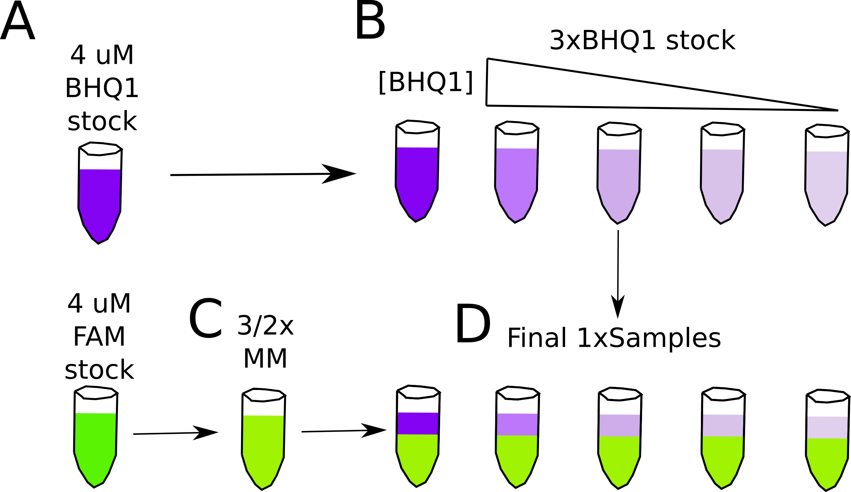

**SI figure 3** Errors in the determination of concentrations of RNA stocks are systematically propagated during sample prep for fluorescence isotherm experiments. **(A)** FAM-RNA and RNA-BHQ1 stock concentrations are determined at a low μM concentrations with UV-absorbance. In this work, FAM and BHQ1 stocks were prepared at the same concentration, 4 μM. **(B)** RNA-BHQ1 stocks are diluted to a 3x concentration from one stock. **(C)** FAM-RNA stocks were diluted to a 3/2xconcentration into artificial cytoplasm to make a master mix (MM).  
**(D)** One volume of 3xRNA-BHQ1 stock is mixed with two volumes of 3/2xMM to prepare the final solution.

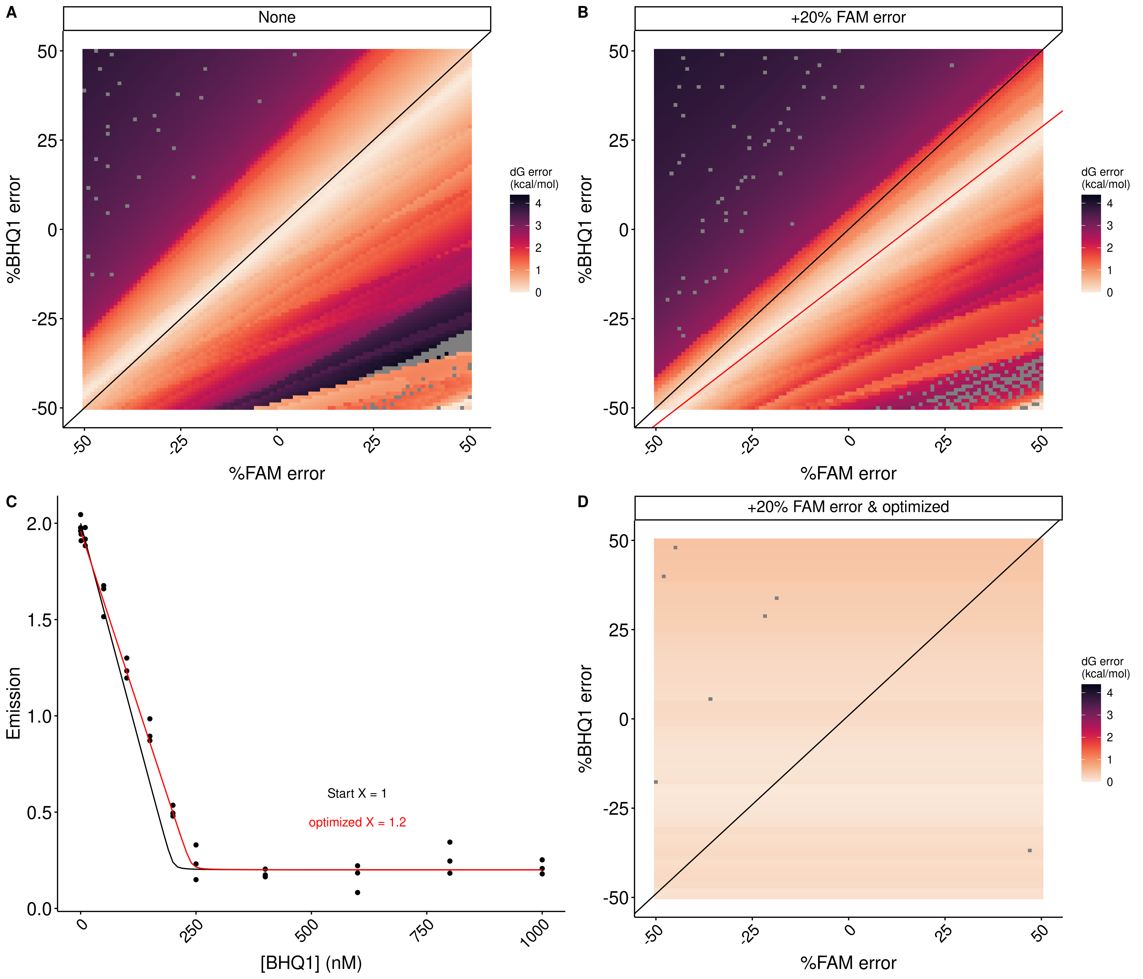**SI figure 4** The concentration optimization algorithm improves the accuracy of helix folding energies calculated with MeltR using data with inaccurate RNA concentration estimates. **(A)** Error in the Gibbs free energy (dG) calculated with MeltR on modeled data assuming perfectly accurate RNA concentration estimates is reduced when the %FAM-RNA concentration error and %RNA-BHQ1 concentration error compensates according to the black line, %FAM-RNA error = %RNA-BHQ1. Data were modeled assuming a folding enthalpy (ΔH), entropy (ΔS), and Gibb’s free energy at 37 °C (ΔG) of -56.2 kcal/mol, -136. 4 cal/mol/K, and -13.9 kcal/mol respectively, and 5% random fluorescence error. Concentration errors were seeded into the modeled data and the data was fit with MeltR. **(B)** Error in the Gibbs free energy (dG) calculated with MeltR on modeled data, assuming a +20% FAM-RNA concentration estimate, is reduced when the %FAM-RNA concentration error and %RNA-BHQ1 concentration error compensate according to the red line, %RNA-BHQ1 = X*%FAM-RNA error + (100 – 100*X)/X, where X is the factor the MeltR concentration optimization algorithm multiplies the FAM-RNA concentration estimate by. Data were modeled assuming a folding ΔH, ΔS, and ΔG of -56.2 kcal/mol, -136. 4 cal/mol/K, and -13.9 kcal/mol respectively, 5% random fluorescence error, and a +20% increase in the FAM-RNA concentration. Additional concentration errors were seeded into the modeled data and the data was fit with MeltR. **(C)** MeltR identifies the FAM-RNA concentration correction factor (X) using a low temperature fluorescence isotherm as a Job plot. Black data points represent modeled fluorescence data from B at 20 °C. The black line represents the shape of the curve with a X of 1. The red line represents the shape of the curve with an optimized X of 1.2. **(D)** Error in the Gibbs free energy (dG) calculated with MeltR using the concentration optimization algorithm and the data from B. On average, MeltR estimates the correct ΔG within 0.2 kcal/mol, using the concentration optimization algorithm.

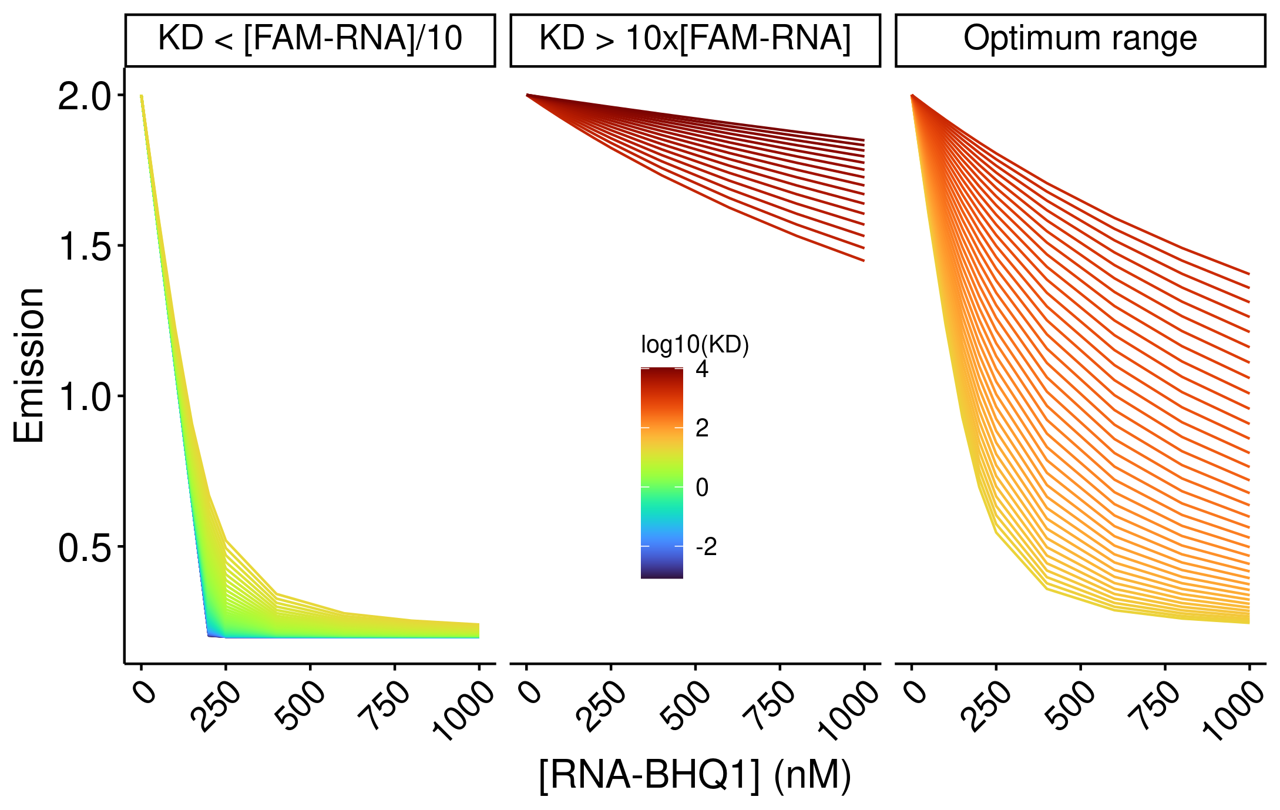**SI figure 5** KDs calculated using MeltR are most accurate between the FAM-RNA concentration/10 and 10 times the FAM-RNA concentration. At KDs that are more than 10 fold lower than the FAM-RNA concentration, the shape of the curve is independent of the KD. At KDs more than 10 fold higher than the FAM-RNA concentration, there is very little dependence of FAM-RNA emission on RNA-BHQ1 concentration. However, the curve shape is highly dependent on KD within the optimum range, so MeltR allows the user to specify an optimum KD range to calculate helix folding energies.

SI table **4**. Stability of RNA helices in *E. coli* **metabolite mixtures. Helix energy was   
calculated by fitting raw fluorescence data with MeltR. Standard errors are estimated from fits. Extra significant digits are included to avoid propagating rounding errors.**

|  |  |  |  |  |  |  |  |  |  |  |  |
| --- | --- | --- | --- | --- | --- | --- | --- | --- | --- | --- | --- |
| Sequencea | Conditionb | Xe | Method 1 VH plot  ΔH kcal/mol | Method 1 VH plot  ΔS cal/mol/K | Method 1 VH plot  ΔG kcal/mol | Method 2 Global fit  ΔH kcal/mol | Method 2 Global fit  ΔS cal/mol/K | Method 2 Global fit ΔG kcal/mol | %Diff.d  ΔG | %Diff.d  ΔS | %Diff.d  ΔG |
| 1:CGCAUCCU/AGGAUGCG | 2 mM free | 1.3 | -55.9 (0.2) | -136.0 (0.7) | -13.82 (0.01) | -56.0 (8.9) | -135.9 (27.0) | -13.8 (0.5) | 0.2% | 0.1% | 0.1 |
| NTPCM | 2 | -52.2 (0.4) | -125 (1) | -13.41 (0.02) | -52.4 (7.6) | -125.6 (23.2) | -13.4 (0.4) | 0.4% | 0.5% | 0.1% |
| WMCM | 1.0 | -61.4 (0.8) | -152 (2) | -14.22 (0.05) | -61.1 (14.0) | -151.2 (42.5) | -14.2 (0.9) | 0.5% | 0.5% | 0.1% |
| Ecoli80 | 1.5 | -44.5 (0.7) | -102 (2) | -12.70 (0.04) | -44.4 (7.6) | -102.1 (23.3) | -12.7 (0.4) | 0.2% | 0.1% | 0.0% |
| 2: CCAUAUCA/ UGAUAUGG | 2 mM free | 0.9 | -53.4 (1.0) | -133 (3) | -12.02 (0.04) | -52.3 (14.9) | -129.9 (43.2) | -12.0 (0.5) | 2.1% | 2.4% | 0.2% |
| NTPCM | 1.3 | -42.9 (0.5) | -101 (1) | -11.50 (0.02) | -42.4 (20.4) | -99.6 (63) | -11.5 (0.8) | 1.2% | 1.4% | 0.0% |
| WMCM | 1.0 | -53 (2) | -132 (7) | -11.9 (0.1) | -51.6 (5.3) | -128.0 (1.6) | -11.9 (0.2) | 2.7% | 3.1% | 0.0% |
| Ecoli80 | 0.9 | -57 (2) | -146 (5) | -11.38 (0.05) | -54.0 (13.1) | -137.7 (-41.1) | -11.3 (0.4) | 5.4% | 5.9% | 0.7% |
| 3:CCAUAUUA/UAAUAUGG | 2 mM free | 0.9 | -53.5 (0.4) | -137 (1) | -10.76 (0.01) | -53.2 (8.4) | -136.7 (27.1) | -10.8 (0.1) | 0.6% | 0.2% | 0.4% |
| NTPCM | 1.0 | -45.0 (0.2) | -112.5 (0.5) | -10.158 (0.002) | -45.0 (8.0) | -112.2 (25.6) | -10.2  (0.1) | 0.0% | 0.3% | 0.4% |
| WMCM | 0.8 | -43 (2) | -107 (5) | -9.94 (0.02) | -40.5 (9.3) | -98.4 (29.6) | -9.9 (0.1) | 6.0% | 8.4% | 0.4% |
| Ecoli80 | 1.2 | -41.3 (0.2) | -100.4 (0.7) | -10.15 (0.01) | -41.2 (9.2) | -100.3 (29.4) | -10.2 (0.2) | 0.2% | 0.1% | 0.5% |
| 4:CGGAUGGC/GCCAUCCG | 2 mM free | 1.1 | -71.1 (0.8) | -179 (2) | -15.6 (0.06) | -71.3 (15.6) | -179.6 (46.6) | -15.6 (1.1) | 0.3% | 0.3% | 0% |
| NTPCM | 1.2 | -70.4 (0.6) | -177 (2) | -15.28 (0.05) | -70.5 (15.1) | -178.0 (45.2) | -15.3 (1.0) | 0.1% | 0.6% | 0.1% |
| WMCM | 1.1 | -65.5 (2) | -162 (7) | -15.2 (0.2) | -65.3 (12.2) | -161.6 (36.4) | -15.2 (0.9) | 0.3% | 0.2% | 0% |
| Ecoli80 | 1.0 | -69.7 (0.8) | -176 (3) | -15.0 (0.1) | -69.6 (11.4) | -176.3 (34.2) | -15.0 (0.8) | 0.1% | 0.2% | 0.2% |
| 5:CGUAUGUA/UACAUACG | 2 mM free | 0.8 | -63.2 (0.9) | -169 (3) | -10.85 (0.02) | -62.3 (7.3) | -165.9 (23.0) | -10.8 (0.1) | 1.4% | 1.9% | 0.5% |
| NTPCM | 0.9 | -59 (1) | -157 (4) | -10.30 (0.01) | -58.5 (7.6) | -155.5 (24.3) | -10.3 (0.1) | 0.9% | 1.0% | 0.0% |
| WMCM | 1.0 | -67 (1) | -180 (3) | -10.85 (0.02) | -66.1 (10.5) | -178.1 (33.2) | -10.8 (0.2) | 1.4% | 1.1% | 0.1% |
| Ecoli80 | 1.0 | -61 (1) | -164 (3) | -10.41 (0.01) | -60.9 (4.09) | -162.9 (13.1) | -10.4 (0.06) | 0.2% | 0.7% | 0.2% |
| Average %error | | | 1.7% | 2.0% | 0.3% | 21.7% | 26.5% | 3.4% | 1.2% | 1.4% | 0.2% |

aThe first sequence was 5’-FAM labeled and the second sequence was 3’-BHQ1 labeled.

bAll solutions contain 2 mM Free Mg, 240 Na+ 140 mM K+.

cConcentration optimization factor used to correct FAM-RNA concentrations by MeltR.

dPercent difference between Method 1 and Method 2.

Table 3. Stability of RNA helices in *E. coli* **metabolite mixtures.**

|  |  |  |  |  |
| --- | --- | --- | --- | --- |
| Sequencea | AU content | Conditionb | ΔG (kcal/mol)c | ΔΔG (kcal/mol)c |
| 1: CGCAUCCU/ AGGAUGCG | 0.38 | 2 mM free | -13.82 (0.21) |  |
| NTPCM | -13.41 (0.20) | 0.41 (0.29) |
| WMCM | -14.22 (0.21) | -0.40 (0.30) |
| Ecoli80 | -12.70 (0.19) | 1.12 (0.28) |
| 2: CCAUAUCA/ UGAUAUGG | 0.63 | 2 mM free | -12.02 (0.18) |  |
| NTPCM | -11.50 (0.17) | 0.52 (0.25) |
| WMCM | -11.90 (0.18) | 0.12 (0.25) |
| Ecoli80 | -11.38 (0.17) | 0.64 (0.25) |
| 3:CCAUAUUA/ UAAUAUGG | 0.75 | 2 mM free | -10.76 (0.16) |  |
| NTPCM | -10.16 (0.15) | 0.60 (0.22) |
| WMCM | -9.94 (0.15) | 0.82 (0.22) |
| Ecoli80 | -10.15 (0.15) | 0.61 (0.22) |
| 4: CGGAUGGC/ GCCAUCCG | 0.25 | 2 mM free | -15.60 (0.23) |  |
| NTPCM | -15.28 (0.23) | 0.32 (0.33) |
| WMCM | -15.20 (0.23) | 0.40 (0.33) |
| Ecoli80 | -15.00 (0.23) | 0.60 (0.32) |
| 5: CGUAUGUA/ UACAUACG | 0.63 | 2 mM free | -10.85 (0.16) |  |
| NTPCM | -10.30 (0.15) | 0.55 (0.22) |
| WMCM | -10.85 (0.16) | 0.00 (0.23) |
| Ecoli80 | -10.41 (0.16) | 0.44 (0.23) |

aThe first sequence was 5’-FAM labeled and the second sequence was 3’-BHQ1 labeled.

bAll solutions contain 2 mM Free3 Mg, 240 Na+ 140 mM K+.

cExtra significant digits were included to avoid propagating rounding errors.

**Figure 3** *E. coli* metabolite and Mg2+ mixtures stabilize the chemical structure of RNA. **(A)** In-line RNA degradation mechanism facilitated by Mg2+. **(B)** Secondary structure of the guanine riboswitch aptamer with tertiary contacts represented by colored lines. **(C)** Degradation rate, by the increase in counts as a function of time at each residue in different solution conditions as a function of location in the RNA. Points represent the slope for the line of best fit and error bars represent the standard error in the slope estimated from the fit. **(D-F)** Estimated increase in counts as a function of time, in different conditions grouped by the structure each base nucleotide, based on analysis of crystal structures and covariation models. Significance was determined using a student’s t-test.

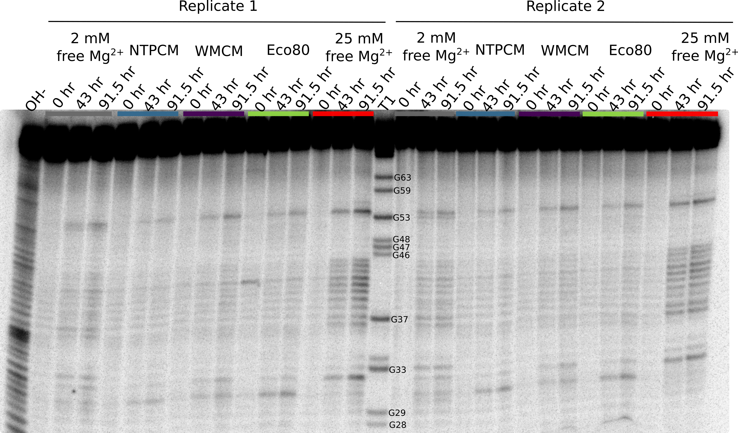**SI figure 6** Raw in-line degradation assay gel image for the Guanine riboswitch aptamer incubated in artificial cytoplasms at 37 °C and pH 7. The OH- lane contains a hydrolysis ladder which cleaves after every nucleotide and T1 contains the RNA treated with T1 ribonuclease which cleaves after every G. Enough Mg2+ was added to each artificial cytoplasm to have 2 mM Mg2+  free as determined in Figure 1. Nucleotides 28 to 63 were quantified. Cleavage fragments shorter than 28 could not be quantified because of band smearing due to the high concentration of charged molecules in the samples and cleavage fragments longer than 63 could not be resolved.

**SI figure 7** Raw in-line degradation assay gel image for the cleaved CPEB3 ribozyme incubated in artificial cytoplasms at 37 °C and pH 7. The OH- lane contains a hydrolysis ladder which cleaves after every nucleotide and T1 contains the RNA treated with T1 ribonuclease which cleaves after every G. Enough Mg2+ was added to each artificial cytoplasm to have 2 mM Mg2+  free as determined in Figure 1. Nucleotides 28 to 63 were quantified. Cleavage fragments shorter than 28 could not be quantified because of band smearing due to the high concentration of charged molecules in the samples and cleavage fragments longer than 63 could not be resolved.

**SI figure 8** Raw in-line degradation assay gel image for the cleaved CPEB3 ribozyme incubated in artificial cytoplasms at 37 °C and pH 7. The OH- lane contains a hydrolysis ladder which cleaves after every nucleotide and T1 contains the RNA treated with T1 ribonuclease which cleaves after every G. Enough Mg2+ was added to each artificial cytoplasm to have 2 mM Mg2+  free as determined in Figure 1. Nucleotides 28 to 63 were quantified. Cleavage fragments shorter than 28 could not be quantified because of band smearing due to the high concentration of charged molecules in the samples and cleavage fragments longer than 63 could not be resolved.



**Figure 3** *E. coli* metabolite and Mg2+ mixtures stabilize the chemical structure of RNA. **(A)** Secondary structure of the cleaved CPEB3 ribozyme with tertiary contacts represented by colored lines. **(B)** Degradation rate, by the increase in counts with time at each residue, in different solution conditions as a function of location in the cleaved CPEB3 ribozyme. Points represent the slope for the line of best fit of counts versus time and error bars represent the standard error in the slope estimated from the fit. **(C)** Secondary structure of yeast tRNAphe with tertiary contacts represented by colored lines. **(D)** Degradation rate, by the increase in counts with time at each residue, in different solution conditions as a function of location in the tRNAphe . Points represent the slope for the line of best fit of counts versus time and error bars represent the standard error in the slope estimated from the fit.

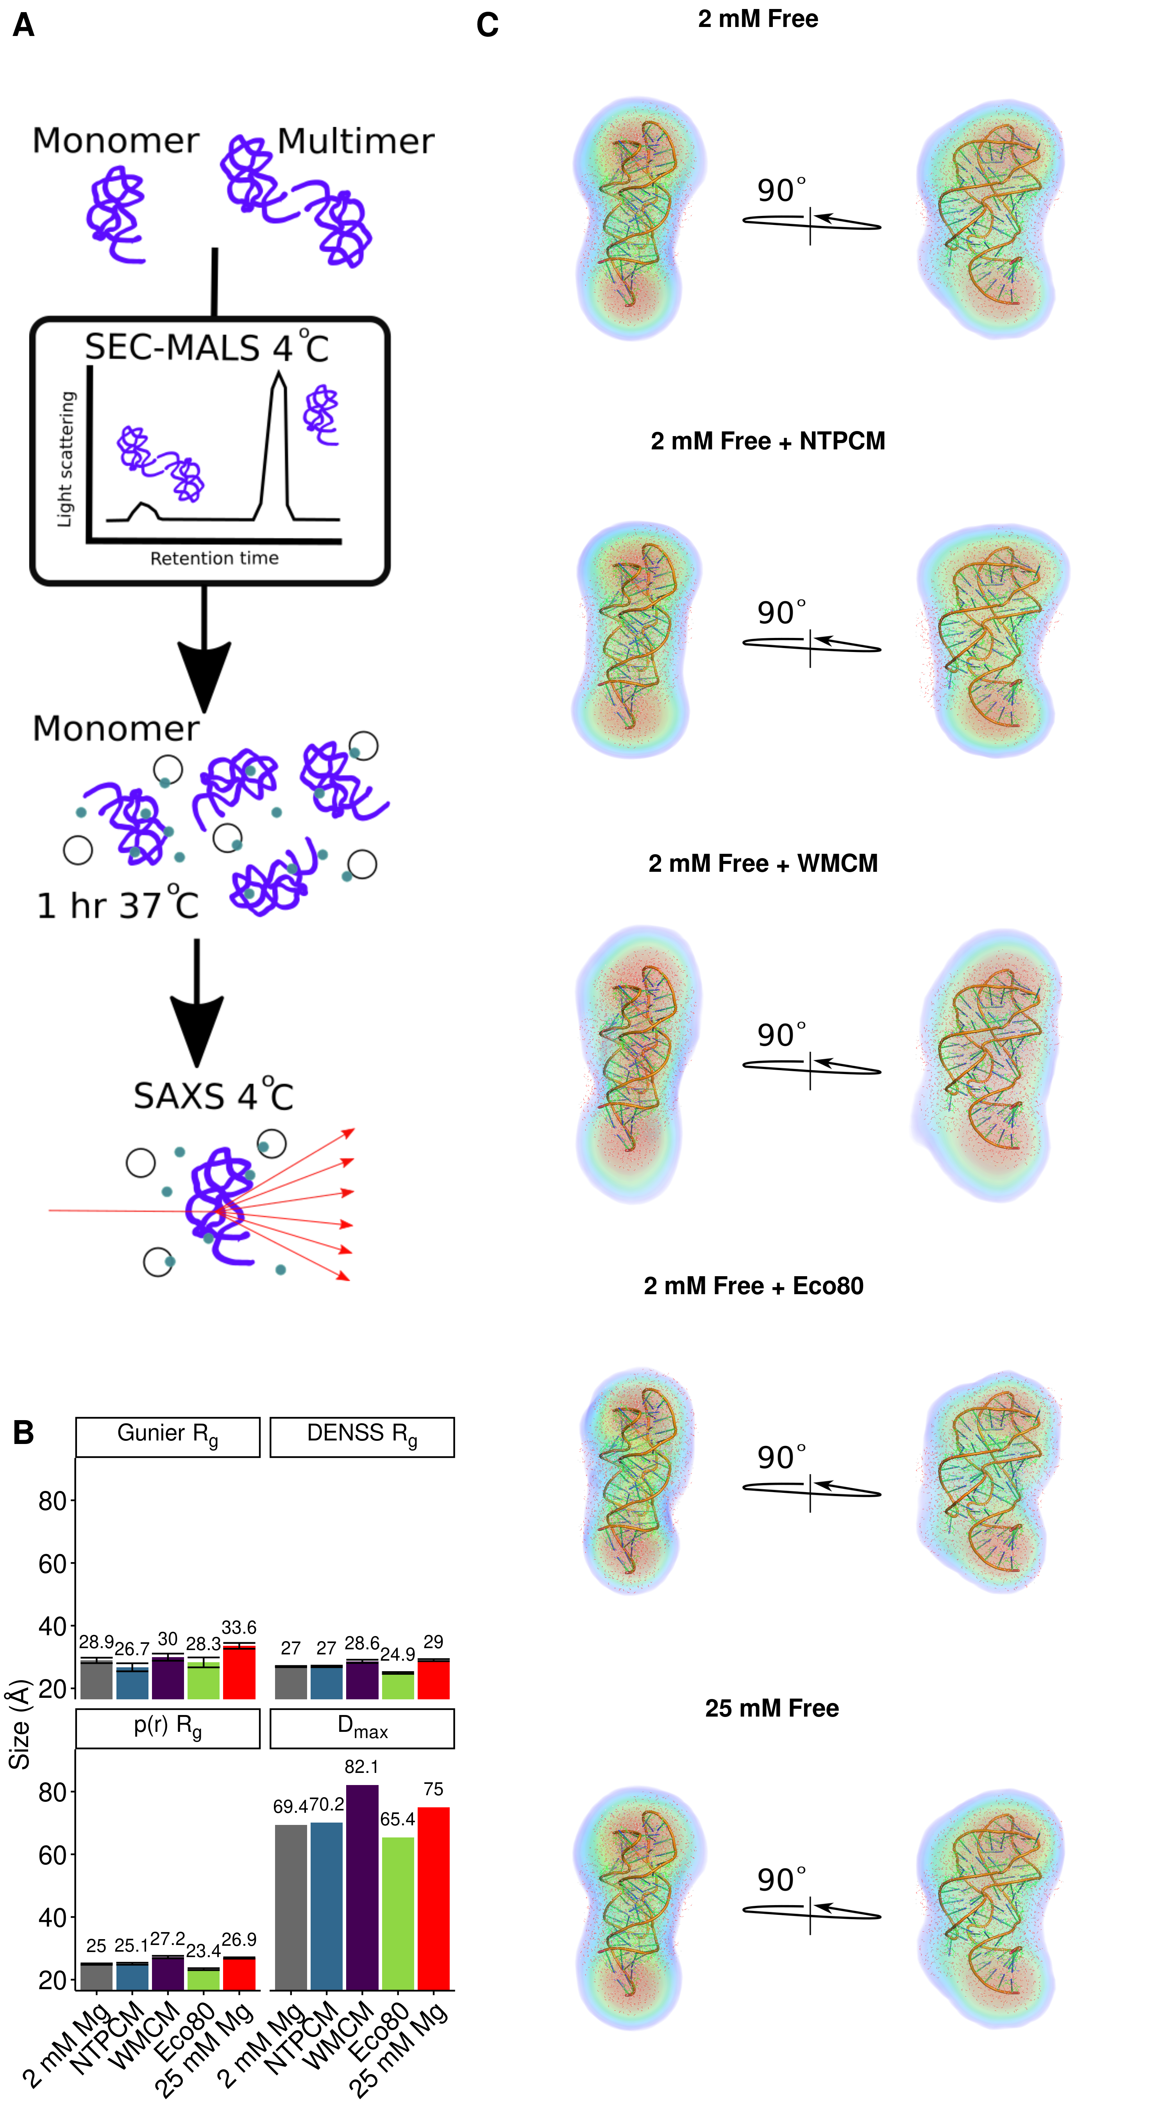

**Figure 4** *E. coli* metabolite and Mg2+ mixtures increase functional RNA compactness.